Molecular Docking Report
In-Silico Analysis of Gefitinib Binding with EGFR

1. Introduction

Epidermal Growth Factor Receptor (EGFR) is a transmembrane receptor tyrosine kinase that plays a crucial role in cell proliferation, differentiation, and survival. Mutations and over expression of EGFR are commonly associated with various cancers, particularly non-small cell lung cancer (NSCLC).

Gefitinib is a first-generation EGFR tyrosine kinase inhibitor (TKI) that selectively inhibits ATP binding to the intracellular kinase domain of EGFR, thereby blocking downstream signaling pathways responsible for tumor growth.

The present study aims to analyze the molecular interaction between Gefitinib and EGFR using in-silico molecular docking techniques to understand binding affinity and interaction stability.

2. Docking Methodology
- Protein Preparation
Target Protein: EGFR Tyrosine Kinase Domain
Structure obtained from Protein Data Bank (PDB)
Water molecules removed
Hydrogen atoms added
Protein cleaned and prepared for docking
- Ligand Preparation
Ligand: Gefitinib
Structure obtained from PubChem database
Energy minimized before docking
- Docking Tool
Docking performed using CB-Dock2
Blind docking approach used
Binding cavity automatically detected
Best binding pose selected based on lowest binding energy score
- Visualization & Interaction Analysis
Docked complex analyzed using PyMOL
Hydrogen bonds and hydrophobic interactions identified
Key interacting residues highlighted

3. Docking Results

The docking analysis revealed that Gefitinib bonds in the ATP-binding pocket of EGFR.
Binding Site: ATP-binding pocket
Interaction Type: Hydrogen bond + π-π stacking + hydrophobic interactions
Binding Pose: Stable and well-oriented inside active site
The ligand showed favorable orientation with key catalytic residues, supporting its inhibitory role.

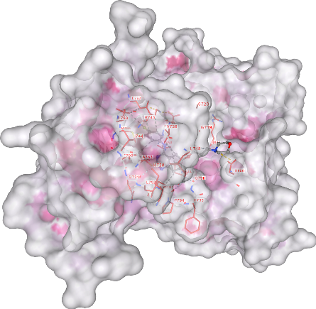

Surface representation of EGFR with Gefitinib bond in the ATP-binding pockets

The docking analysis revealed that Gefitinib binds within the ATP-binding pockets of EGFR with stable orientation.

4. Interaction Analysis

Detailed interaction analysis identified the following critical residues:

Residue | Interaction Type | Significance
MET793 | Hydrogen bond | Stabilizes ligand binding within ATP
PHE795 | π–π stacking interaction | Aromatic interaction enhances stability
LEU718 | Hydrophobic interaction | Contributes to non-polar stabilization
VAL726 | Hydrophobic interaction | Supports ligand anchoring in pocket

🔹 Key Observations:
A strong hydrogen bond was observed with MET793, a critical residue in EGFR kinase activity.
PHE795 formed π–π stacking interaction with the aromatic ring of Gefitinib.
LEU718 and VAL726 contributed to hydrophobic stabilization of the complex.
The interactions collectively indicate stable ligand binding within the active site.

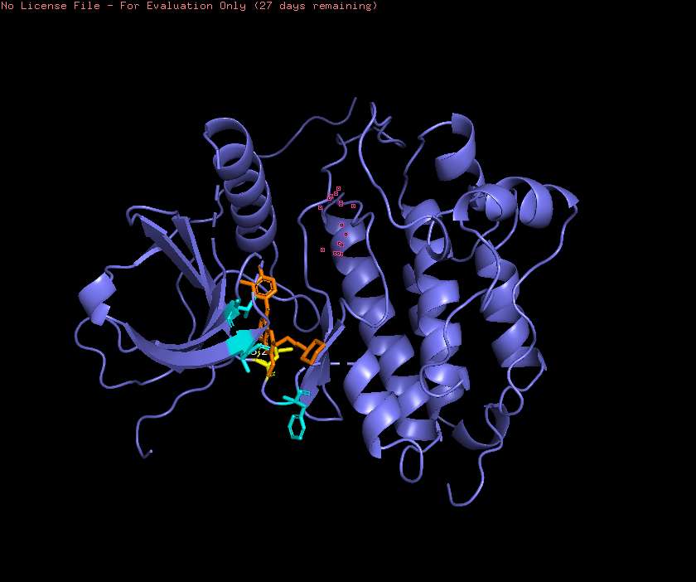

Interaction analysis showing hydrogen bond with MET793, π–π interaction with PHE795, and hydrophobic interactions with LEU718 and VAL726.

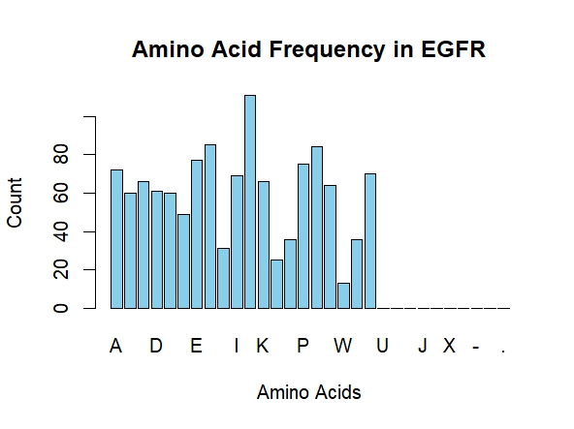

Amino acid interaction profile of Gefitinib within EGFR binding pocket.

5. Biological Significance

The interaction of Gefitinib with MET793 is particularly important because this residue plays a vital role in ATP binding and kinase activation.

By occupying the ATP-binding pocket:
Gefitinib prevents phosphorylation.
Blocks downstream signaling pathways
Inhibits tumor cell proliferation
The presence of hydrogen bonding and hydrophobic interactions suggests strong binding affinity and supports the drug's mechanism as an EGFR tyrosine kinase inhibitor.
This in-silico analysis aligns with experimental findings reported in literature regarding Gefitinib’s inhibitory mechanism.

6. References

Yun CH, et al. (2007). The T790M mutation in EGFR kinase causes drug resistance. PNAS.

Lynch TJ, et al. (2004). Activating mutations in EGFR underlying responsiveness to Gefitinib. NEJM.

CB-Dock2: Improved protein–ligand blind docking server.

DeLano WL. (2002). PyMOL Molecular Graphics System.

